Impact of Management Role on Innovation
Name
Institution Affiliation

Abstract
To attain sustainable implementation of creativity and innovation, business organizations are required to engage the commitment of their employees and external stakeholders. This paper will look the views and suggestions of the employees, on what their companies do to enhance the adoption and implementation modern technology to encourage them to positively impact innovations and curb challenges associated with disruptive innovations. The focus group comprise of six employees .The study found that the top priorities of the employees for action of implementing and encouraging creativity and innovation were: top level managers carrying out planning, organizing, controlling and leading roles, communicating their organization’s innovations ambitions convincingly; frontline and middle managers proactively promoting innovations; business entities through their mangers safeguarding time as well as physical, financial, and human resources for developing appropriate innovations. The views of these employees concerning the priorities for implementing effective innovative business strategies were contrasted with the chief executives’ views.

Impact of Management Role on Innovation
Introduction
Generally, management is described as the group of people who decide how an organization is going to be structured. This group of people determines how various aspects of an organization will run and how they will interact with each other. In deciding the way an organization will run, managers will often consider factors such as reliability of the system they put in place, how flexible it is, its adaptability to new environment, how economical it is to implement and acceptability by different stakeholders. Managers will identify the moving parts of an organization which adds value to the company and ensures that these parts work in tandem to function efficiently and effectively. Managers look at the functioning of a company in whole without thinking of individual departments, processes or individuals. This helps them come up with harmonious systems that link all the department in the company in the most effective way in order to help the company minimize costs and risks while maximizing returns to the company both in the short and long run. In trying to achieve this endeavor, managers perform different four managerial roles; planning, organizing, controlling and leading.
To plan, managers come up with viable processes to ensure the company clearly define their goals for the future and source and allocate resources to be used to achieve those goals. This is normally done by drawing business plans which clearly define the mission, vision and the process of achieving them. After setting the goals for the organization, managers proceed to come up with ways to ensure all parts and department pull in the same direction in towards achieving the overall goals. Managers also have to perform a controlling role in the company. They do this by setting standards to be met by different departments and individuals in the organization, measuring their performance against the set standards and taking corrective measure in the event performance is not up to par. To achieve all of this, managers have to be adept at leading. They accomplish this function by ensuring smooth communication within the organization, using different tools to motivate and inspire their employees to strive to achieve higher productivity levels.
Innovation is the process of coming up with new and better products and processes in an organization. To perform this function, managers have to make sure their organization introduce new products to the market, implement new and better processes in the way they perform their functions or both. This is normally done through research and development. This process helps managers look for new ideas and ways of solving the different problem an organization faces. This can be done at any stage in the product lifecycle. Innovation takes different shapes. Product innovation is when a new or greatly improves product or service is introduced to the market. This can be in terms of technological advancements, new components, and software. Process innovation on the hand describes an improvement in the production or the way a product or service is delivered to customers. This can include new or improved techniques or equipment used. Marketing innovation looks at how an organization repackages its products in the market through pricing, packaging, and design. Organizational innovation looks at the different methods employed by an organization in how they run their operations, the workplace or any related external relationships with other organizations.
Literature Review
Regardless of the organizational structure, be it hierarchies, juries, matrix or ecologies innovation is vital to organizations stability and continuity. This has been amplified by the globalization and high levels of competition in the marketplace. Lewis, Welsh, Dehler, & Greens in their paper looked management tensions, that is, how managers cope with changing contingencies in their organizations in order to ensure innovation and efficiency. They explored the nature, dynamic forces and effects of different management styles. They followed a total of 80 projects in a span of 2 years to determine how different management styles help to shape up innovation in their respective organizations. They found out that managers use a cocktail of this interwoven approaches to monitor, evaluate, and control activities. They found out that different managers use diverse approaches to suit their current situation and that they employ a cocktail of paradoxical approaches which when bent together enhance the organizations' total performance. From their study, it became apparent that companies needed to concentrate their effort in product development. This helped them gain a competitive advantage over their competitors and helped the organization remain relevant in the market in the long run. The success of these organizations was often elusive. Most organizations found themselves contradicted in their objectives. This manifested itself in form of conflict between an organization need to satisfy external demand while taking into considerations internal competency of the organization, its desire to spontaneously change according to the environment against its need to come up with concrete structures and its desire to change with times and customer needs and its desire for stability (Lewis, Welsh, Dehler, & Green, 2002). To ensure successful implement their innovative strategy in the market, management has to come up with technological and innovative ways to come up with products and processes which are commercially viable by building their capacity while ensuring efficient execution and implementation of projects in time and on budget. From their findings, Lewis, Welsh, Dehler, & Greens concluded that no management style is mutually exclusive of each other. Each style has its pros and cons. it is up to the management to analyze and evaluate which method works best for them and at what time. This makes sure companies come up with an innovative combination of operations which help the organization minimize its costa and maximize its profits. Theirs is an exploratory study, most of their basis was based on team interactions with personnel from a different department.
Depending on where the pressure is originating from, companies employ different strategies to be innovative in the market. Taking into account globalization, companies have to look into ways to competitively compete for both in the local and global market. Technological advancement has made it possible for the client to source for products and services from both their countries and abroad. This necessitates companies to be more innovative so as to acquire new markets in other countries. If the pressure on the company is external, companies ten to employ strategic control to gain a competitive advantage. If the pressure is internal, companies will employ financial control over their expenditure to gains a competitive advantage over their competitors (Li, Li, Liu, & Wang, 2005). Li, Li, Liu, and Wang looked at the current global market and how I affect innovations and management styles. Globalization has led to an increase in the markets an organization can venture into. Industrialization has led to a race in industrialization. Countries like China are investing more, both politically and economically t gains more markets all over the world. This high competition has led to a reduction in product life cycles and an acceleration in the adoption of technology globally. This has led to more demand to companies by its customers and increasing complexity in the business environment. They conducted a survey on manufacturing industries in China, assessed successful experiences in both local and global market and highlighted the areas they need to improve. To be successful, managers have to come up with innovative ways to adapt to the market. Managers will through their roles come up with strategic products and processes to meet the ever-changing needs of their customers. They also have to strategically adapt to a new environment which is different politically, economically socially and legally. A business which does not look at ways to change its traditional methods of doing business will likely not survive. Managers have to formulate viable business plans which can be functional in the market such as continuous product development, improvement of manufacturing processes and better marketing strategies. This study confirmed that companies which formulate their strategies with their environment in mind are able to compete better in the market. Managers in these organization are able to align their management strategies with their manufacturing processes to come up with innovative products and services which appeal to consumers in their countries and all over the world. This study looked at the Chinese business environment, its complexity and how this impacted the choice of control system employed by managers in this companies. It also looked at the effect of varying control systems by managers in how their organizations produce their products and services and the decision process involved in achieving that. The quadrant looked at companies in different industries ranging from food, machinery, pharmaceuticals, electronics, apparel and textile, commercial products, metallurgical, chemical and communication equipment from 8 major cities and provinces in China. Managers who employed strategic control in the product and process innovation decision ended up incurring more cost. This was however offset by the benefit in terms of increased sales especially if the company took the time to invest in extensive research and development. In this model, top managers will communicate their strategic decision to their subordinate. This triggers functional managers to research their competitors’ actions and their processes. Using this information, functional managers will come up with innovative ways to improve their processes with the support of management. This approach affects both product and process innovation. For a company to effectively come up with new innovative products, managers have to employ better and improved processes to help them in their manufacturing. This leads to an advancement in the processes. Companies which fail to adopt better and advanced production methods end up end up being ended out of the market by those who do.
Using financial control in their product and decision making, managers use short-term financial key performance indicators to measure their performance. Companies which employ this strategy tend to be less innovative. Since managers are remunerated by their performance, managers may be skittish in taking on innovative projects. This is because new projects may result in unpredictable outcomes an outcome many managers in this school of thought may not be willing to take on. Managers who prescribe to his method prefer making incremental changes in areas in which they perform well at the moment in order to achieve positive results. Management strategies such as lean production where managers are able to eliminate any extra inventory they hold, do away with extra staff and reduce extra space have come in handy. This ensures that organizations are able to minimize their costs, reduce the number of defects products and achieve high levels of productivity flexibility enabling them to bring products into the market faster and more efficiently. Even though this model of management reduces the level of innovation, it increases the level of competitiveness of the company in the market. This means a company is guaranteed of making more profits in the short run. Because these managers are more concerned with short-term returns on investment, they tend to overlook research and development infamous for improving internal manufacturing processes. These companies end up losing on the benefit of innovation which leads to the acquisition of new markets (Li, Li, Liu, & Wang, 2005). This research confirmed that managers in a company used different strategies to influence innovation in their organizations depending on the complexity of the environment they operate in and the system of control they employ in their management.
(Lyon & Ferrier, Walter J., 2002) concentrated their research on the impact of top management in the organization and how their actions enhanced the performance of their product in the market through innovation in their products and marketing. Cutthroat competition and exponential growth in technology have made it difficult for companies to maintain their competitive advantage in the market. To counter these effect top managers, have to come up with innovative mechanisms to remain relevant in the market. This has prompted managers to continuously look for new strategies in their investment models in order to remain competitive in the market. They took a keen interest on whether organizations top management play a role in how the company chooses to engage in the market. A company that comes up with innovate ways to produce and market its product gains a competitive advantage in the market.
Even though innovation is expected to be directly proportional to an organizations performance, management style also influences how organization innovative activities are carried out. Entrepreneurial posture decisions are greatly influenced by the nature of top management. This is because this group is ultimately responsible for the direction an organization takes. The decision they come up with determine which direction the company will take. Based on their values perspectives, experiences and cognitions, top managers formulate strategies which reflect their collective nature.
Hypothesis
The present study aims to analyze how managerial roles such as planning, organizing, directing and controlling impacts innovation development and implementation in various business organization.
Methods
The selection of participants for the research is important and pragmatic. The section of the managers and the chief executive were partly done for practical purposes, for instance their willingness to be interviewed. Because there was no compulsion for the participants to be involved .In this study, the chief executive officer and managers of Starbucks Inc. were selected as the focus group of the research. The focus group was first briefed the objective of the interview to acquire up to date information concerning the key managerial and innovation issues. The employees attending the interview wanted the management of Starbucks Company to consider the priorities for action to develop and encourage innovation and creativity. One of the priorities for action, the senior managers are required to communicate the company’s innovative ambitions convincingly.
Example of what Starbucks workers said as a priority for action

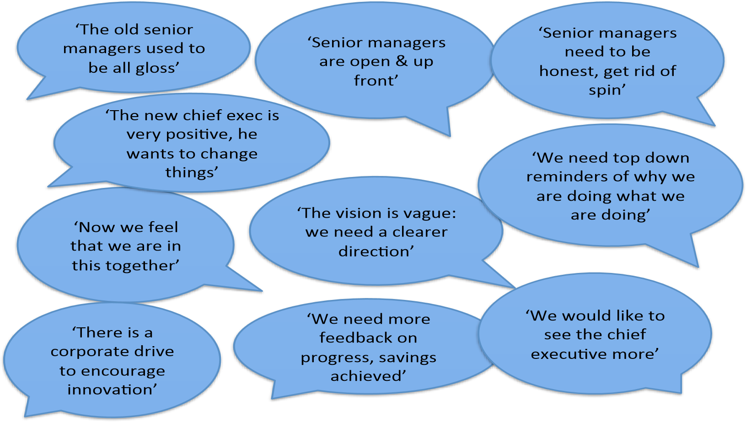
Starbucks employees wanted the organizations managerial staff and chief executive to explain the adverse challenges that the company may encounter in future and to set out specific, measurable, achievable, realistic and time bound goals and priorities for their organization. They claimed that the senior managers should plan effectively and efficiently for the company’s future innovative environment.
Data Analysis
The questioned that were asked during the interview of the Starbucks company Chief executive and the human resource manager are summarized in the table below
Table A
Questions | Chief executive Officer | Managers
Are the managers and leaders efficiently encouraging and developing innovation? | Top priority of the company | Top priority of the organization
Is the top level mangers safeguarding time and enough resources for innovation? | Some managers were mentioned | Not mentioned
Are the managers setting enough, but appropriate, pace? | Top Priority | Not all managerial departments
Are the managers united, forward looking and bold in addressing the issue of innovation? | Medium priority | Not all managerial departments that support the development and implementation of innovation
Does managers full comprehend and operate processes of innovation and modern techniques? | Not all, but the company has established innovation mentorship programmes | Top priority
Do frontline managers and leaders support the organization’s employees in innovating? | Yes, but not sufficient | Top priority
Does the company have clear and appropriate accountability for techniques and innovation process? | Yes, but more need to be done | No

Results and Discussion
The human resource manager and the chief executive officer Starbucks Company highlighted several similar priority actions as being the appropriate and effective ways the organization could implement and encourage creativity and innovation. The chief executive officer acknowledged that leaders and managers should be provided with enough resources to carry out innovative processes, and enough time to for creative thinking as well as for encouraging and implementing innovations.
The chief executive officer discussed about the benefit of making sure that the organization’s managerial staff are provided with enough physical, financial, human, and technological resources to encourage and promote innovation. For example the CEO said, “Having a custom that expects all leaders and managers to try new strategies is the most crucial thing”. Therefore, the managers influence the development and implementation of innovation through the four managerial functions such as planning, organizing, directing and controlling, thus the research hypothesis is true.

Conclusions
Regardless of the model employed by an organization, it is apparent that managers play a very important role in deciding on the innovative activities their organizations engage in. with globalization and liberalization of markets across the world, organizations have access to external markets. This means they have to compete not only within their border but also outside their borders. Technology has also amplified the need for companies to innovate. With customers connected to the internet and able to access and review products from all over the world, companies have to come up with innovative ways to ensure they can compete with others otherwise they will be rendered useless. Since managers play the key roles in planning, organizing and controlling they are at the center stage of this dynamic business process. No particular model can assure managers that their companies will always remain at the top. Instead, companies have to continuously invest time and resources to scan and capture changing trends in time the go back and realign their products and processes to ensure they make remain ahead of the pack. Failure to do this means the company will lose their market share to competitors making fewer profits in the process. If managers fail to play their role in ensuring their organizations are innovative, then they will define be edged out of business or rendered obsolete.

Références
Defining Organization. (n.d.). Retrieved from Boundless Management: https://courses.lumenlearning.com/boundless-management/chapter/defining-organization/
Hughes, A. (2001). Innovation and business performance: Small entrepreneurial firms in the UK and the EU. New Economy. .
Lewis, M. W., Welsh, M. A., Dehler, G. E., & Green, S. G. (2002). PRODUCT DEVELOPMENT TENSIONS: EXPLORING CONTRASTING STYLES OF PROJECT MANAGEMENT. Academy of Management Journal, 546-564.
Li, Y., Li, L., Liu, Y., & Wang, L. (2005). Linking management control system with product development and. International Journal of Production Research, 2577-2591.
Lyon, D. W., & Ferrier, Walter J. (2002). Enhancing Performance With Product-Market Innovation: The Influence Of The Top Management Team. Journal of Managerial Issues., 452.
Manimala, M. J., Jose, P. D., & Thomas, K. R. (2005). Organizational Design for Enhancing the Impact of Incremental Innovations: A Qualitative Analysis of Innovative Cases in the Context of a Developing Economy. Creativity & Innovation Management, 413-424.

